EXAMPLE OF PAPER
PAPER TITLE
............(skip a line)........

D.A. Petrov¹, A.M. Sidorov²
............(skip a line)........
¹Sakhalin Department of Far East Geological Institute FEB RAS,
Yuzhno-Sakhalinsk, Russia;
²Branch of public corporation "Russian railway" far Eastern railway Center of diagnostics and monitoring of infrastructure devices, Yuzhno-Sakhalinsk, Russia
............(skip a line)........
Summary. (not more than 100 words). Font - Times New Roman Cyr. Font height – 10pt, line spacing-single
............(skip a line)........
Key words: (not more than 5 words) Font - Times New Roman Cyr. Font height – 10pt
............(skip a line)........
No more than 5 pages of A4 (210×297) format. Document format – «.doc», «.docx». Document margins: top, bottom, left – 2,5 cm, right – 1,5 cm. Font – Times New Roman Cyr. Font height – 14pt. Line spacing – single. Break line– 1,0 cm. Width alignment page.
Figures (fig.1): gray scale, 300 dpi, «.jpeg». Figures are presented in a separate file format, and should be placed directly in the text. Figure number and caption placed below the figure.
............(skip a line)........
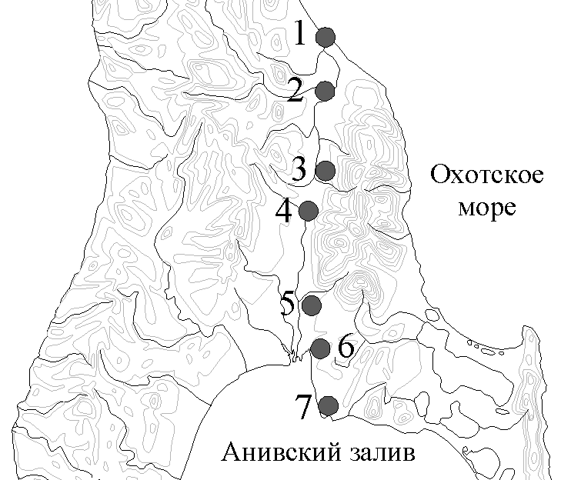
Figures 1. Arrangement of observation points.
............(skip a line)........
Table (tab. 1) should be placed in the text of the report. Font into a table: Times New Roman Cyr., font height – 12pt. Line spacing – single. Table number and name are placed above the table.
............(skip a line)........
Table 1.
Table name
............(skip a line)........
Equations – if using Word, provide equations in an editable form (so they can be typeset)
Reference to the bibliographic source (Sidorov, 1995).
............(skip a line)........
References (not more than 10 bibliographic sources)
1. Sidorov D.K. Seismicity of the Baikal rift // Pacific geology. 1995, № 5. P.103-108.

